**Date and Time functions**

1. Write a query to display the first day of the month (in datetime format) three

months before the current month.

Sample current date : 2014-09-03

Expected result : 2014-06-01

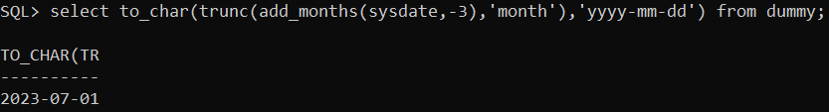

2. Write a query to display the last day of the month (in datetime format) three

months before the current month.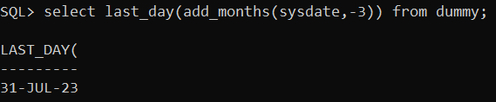

3. Write a query to get the distinct Mondays from hiredate in emp tables.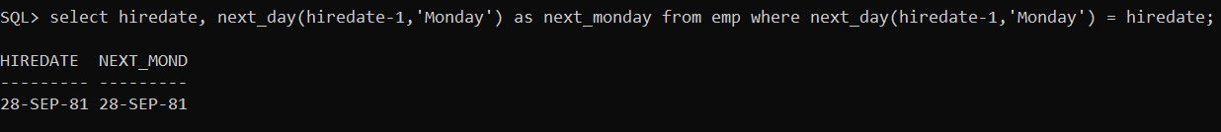

4. Write a query to get the first day of the current year.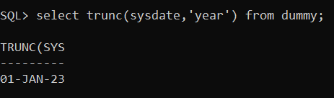

5. Write a query to get the last day of the current year.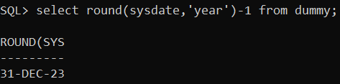

6. Write a query to calculate your age in year.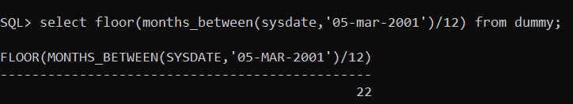

7. Write a query to get the current date in the following format.

Sample date : 04-sep-2014

Output : September 4, 2014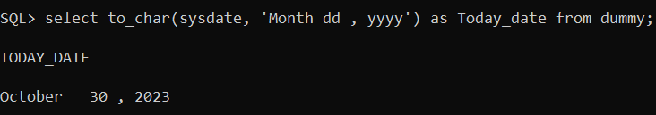

8. Write a query to get the current date in Thursday September 2014 format.

Thursday September 2014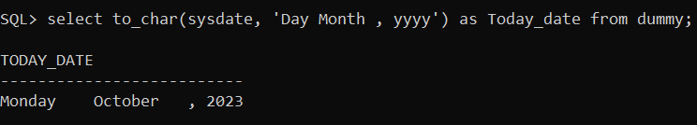

9. Write a query to extract the year from the current date.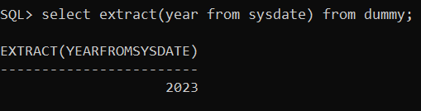

10. Write a query to get the first name and hire date from employees table

where hire date between 1-Jun-87' and '30-jul-87’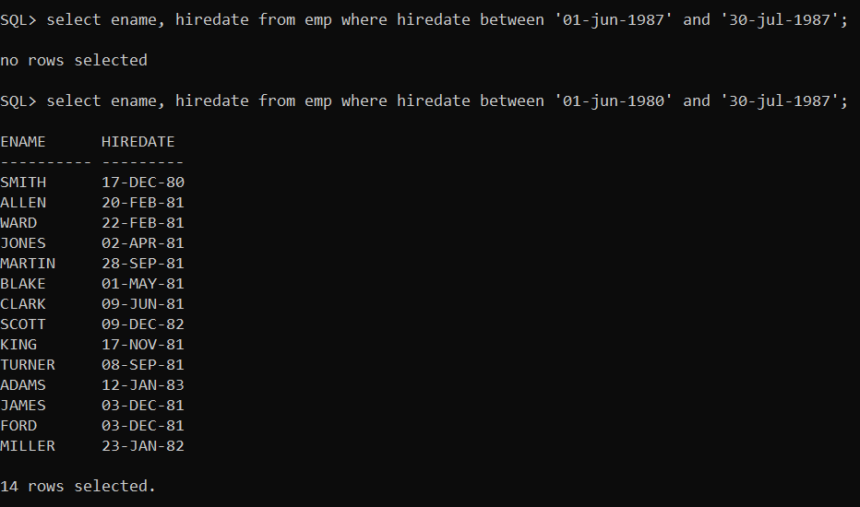

11. Write a query to display the current date in the following format.

Sample output: Thursday 4th September 2014 00:00:00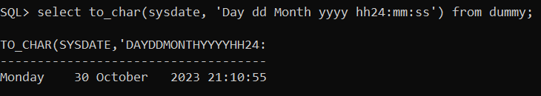

12. Write a query to display the current date in the following format.

Sample output: 05/09/2014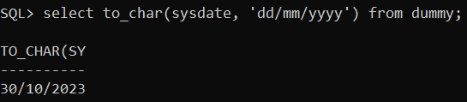

13. Write a query to display the current date in the following format.

Sample output: 12:00 AM Sep 5, 2014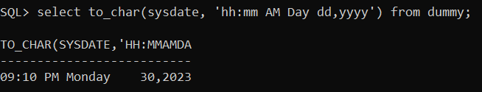

14. Write a query to get the employees who joined in the month of June.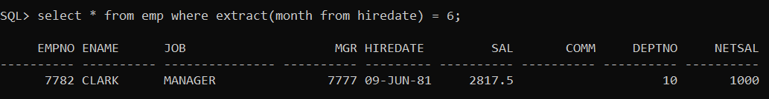

15. Write a query to get the years in which more than 10 employees joined.

16. Write a query to get first name of employees who joined in 1987.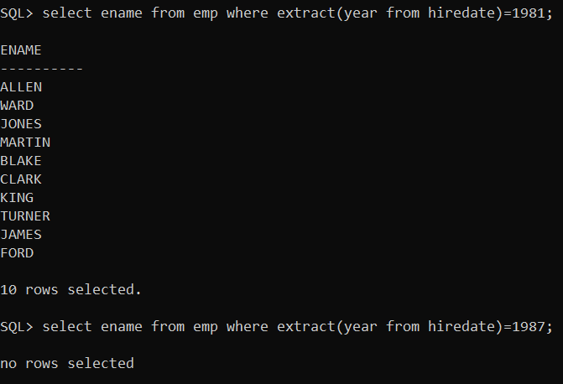

17. Write a query to get employees whose experience is more than 5 years.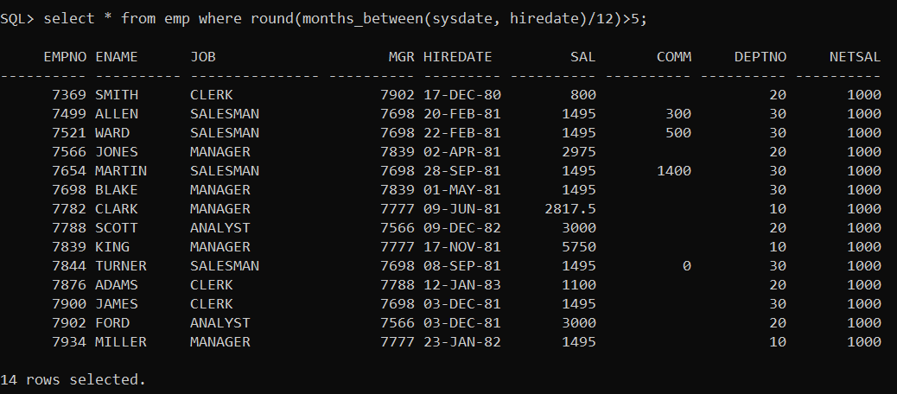

18. Write a query to get employee ID, name, and date, salary of the employees, display salary with $ symbol and thousand separator.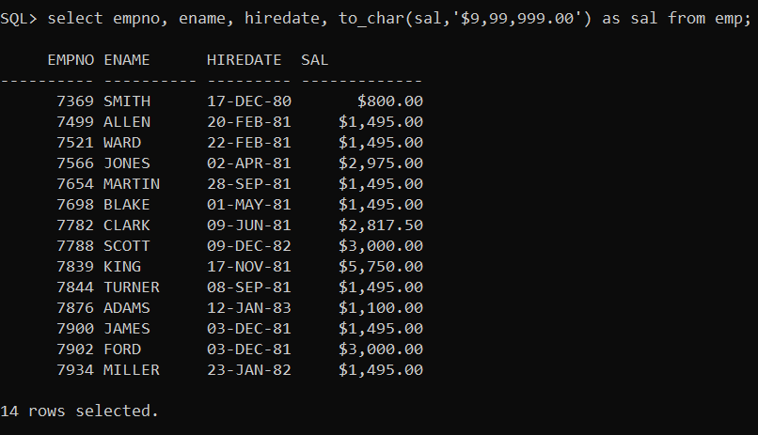

19. Write a query to get name, hire date and experience of the employees.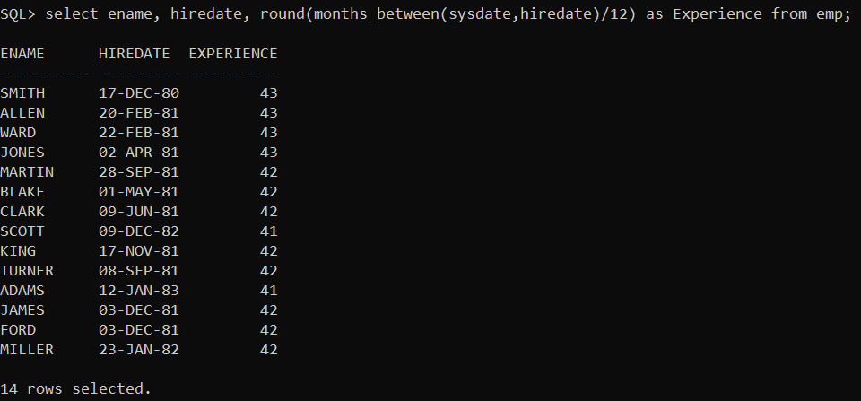

20. Write a query to get the department no, year, and number of employees

joined.